Print or type all details on this application form.
Sponsoring Kiwanis Club:_________________________
Point of Contact for Club:
Name/Title: _______________________________
Telephone #:_____________ Email: _________________
Name of Nominee: _____________________________
Address: _____________________________________
City: __________________ State: _____ ZIP: ________
Telephone #: _____________ Email: __________________
University name: ____________________________
Student ID #: _______________Major: __________________
Please provide a narrative of how this young person has dedicated themselves unselfishly to making the world a better place on the following page (must be completed by the sponsoring Kiwanis Club).
Guidelines:
- We are looking for extended community service that reaches beyond our own borders.
- The nominee is not required to have been or be a member of Key Club or CKI to be considered.
- No need to provide official transcripts.
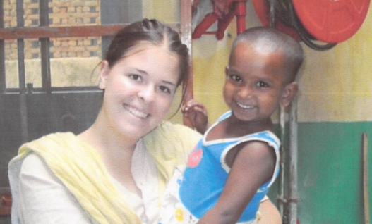
Deadline is June 18, 2021
Email this completed form and the narrative on the next page to our Southwest District Executive Director, Kenneth Garley at swd@swdkiwanis.org.
If you would like assistance completing the form electronically, please contact Lynette Kennard, swdchildrensfund@gmail.com or 505-660-6239. We appreciate your participation!

Name of Nominee:
Narrative of how this young person has dedicated themselves unselfishly to making the world a better place:

